20. Perform Sharpening of Image Using Laplacian Mask with Negative Center Coefficient
Aim
To sharpen an image using a Laplacian mask with a negative center coefficient in Python with OpenCV.
Procedure
- Import the OpenCV and NumPy libraries.
- Read the input image.
- Define the Laplacian sharpening kernel with a negative center coefficient.
- Apply the kernel to the image using the filter2D() function.
- Display the original and sharpened images.
- Close all windows after a key is pressed.
Python Code
import cv2
import numpy as np

# Read the image
image = cv2.imread("image.jpg")

# Laplacian sharpening mask with negative center coefficient
kernel = np.array([[0, -1, 0],
[-1, 5, -1],
[0, -1, 0]])

# Apply the sharpening filter
sharpened = cv2.filter2D(image, -1, kernel)

# Display images
cv2.imshow("Original Image", image)
cv2.imshow("Sharpened Image", sharpened)

# Wait for a key press
cv2.waitKey(0)
cv2.destroyAllWindows()

Output
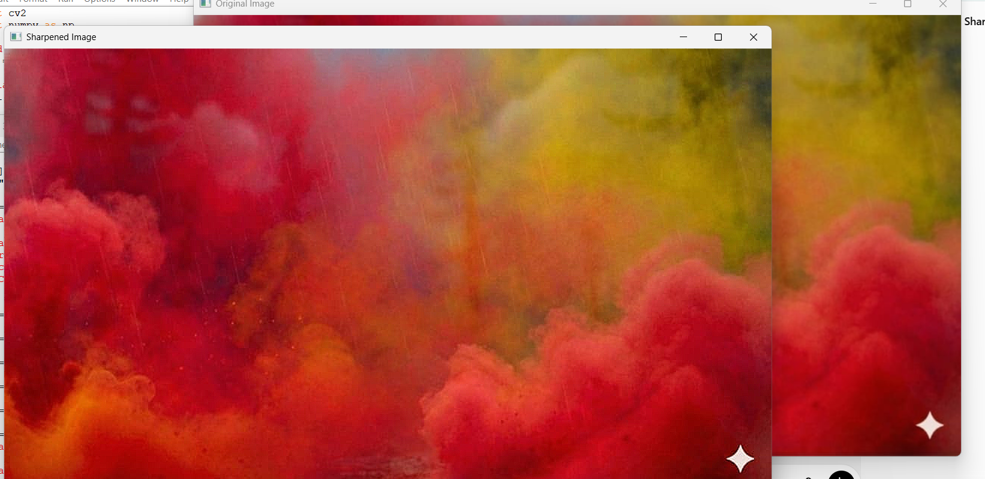
Result
The given image was successfully sharpened using a Laplacian mask with a negative center coefficient in Python with OpenCV.

